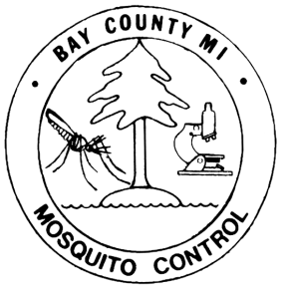**Bay County Mosquito Control**

810 Livingston Street

Bay City, MI 48708

(989) 894-4555 Phone (989) 894-0526 Fax

**morenom@baycountymi.gov**

# 2025

# Medical Certification Form

*Valid for Current Year Only*

This is to certify that the patient listed below is severely allergic to mosquito bites or has a serious health problem and requires specialized treatment. Please fill this form out completely.

**HEALTH CARE PROVIDER INFORMATION**

_______________________________________

Health Care Provider Name (*Please print*) Health Care Provider Signature

Address City State Zip

Phone Number Fax Number

Please state reason why it would be beneficial for patient to receive additional mosquito

control services

**PATIENT/GUARDIAN INFORMATION**

Name of Patient Guardian (if patient is under 18)

Street Address City State Zip

Township Crossroads

Phone Number Email Address (optional)

**Patient/Guardian Signature & Date**

***For office use only***

Entered in Database  Mapped

Twp ________________ Section # _______ Date Received ______________